NAME: Joshua LeGoff INSTRUCTOR: George R. Saban

[25-points]
Part II instructions – This part of the exam is open everything including books, notes, and the Internet. On average, part II (the practical project-based part) of an exam can be completed in 1 ½ hours. Students are encouraged to apply their management skills in balancing contending priorities of time, features, and cost. No deduction incurred if you exceed the aforementioned average time of completion. However, there will be a 1-point per minute deduction if you submit your work after the scheduled class time. Therefore, plan your work accordingly. Consult your instructor for your specific time deadline. Moreover, submit part I first before answering part II. There should be no coaching to other test-takers, or talking to others during the examination. All questions and clarifications should be directed to the faculty. If it is all possible--set separately from your classmates--there should be at least one empty seat separating you from your classmate on either side. Now, let us begin . . .

The purpose of this practical exam is to look at a practical application of algorithms to solve real life and engineering problems.



Queues are frequently used on simulation. In queuing theory various scenarios are analyzed and models are built that use queues. A few of these examples are web servers hit by different request, lanes in highways traversed by x number of vehicles, toilet in the bathrooms available for x number of men or women, AI actions to be executed, parts on an assembly line, trucks waiting for service at a weighing station on an interstate, barges waiting for a sluice to be opened so they can pass through a channel, or meshes to be rendered. The most familiar examples are lines in stores, post offices, or banks.

In queuing processes, there are a number of customers coming to servers to receive service. The throughput of the server may be limited. Therefore, customers have to wait in queues before they are served and spend some amount of time while they are being served. By customers, we mean not only people, but also objects. The types of problems posed in simulations are: How many servers are needed to avoid long queues? How large must the waiting space be to put the entire queue in it? Is it cheaper to increase this space or to open one more server?

As an example, consider Bank One which, over a period of three months, recorded the number of customers coming to the bank and the amount of time needed to serve them. The table in Figure 1a below shows the number of customers who arrived during one-minute intervals throughout the day.

Figure 1. Bank One example: (a) data for number of arrived customers per one-minute interval and (b) transaction time in seconds per customer.
Number of Customers per Minute | Percentage of One-minute Intervals | Range |  | Amount of Time Needed for Service in Seconds | Percentage of Customers | Range
0 | 15 | 1 – 15 |  | 0 | 0 | –
1 | 20 | 16 – 35 |  | 10 | 0 | –
2 | 25 | 36 – 60 |  | 20 | 0 | –
3 | 10 | 61 – 70 |  | 30 | 10 | 1 – 10
4 | 30 | 71 – 100 |  | 40 | 5 | 11 – 15
 |  |  |  | 50 | 10 | 16 – 25
 | (a) |  |  | 60 | 10 | 26 – 35
 |  |  |  | 70 | 0 | –
 |  |  |  | 80 | 15 | 36 – 50
 |  |  |  | 90 | 25 | 51 – 75
 |  |  |  | 100 | 10 | 76 – 85
 |  |  |  | 110 | 15 | 86 – 100
 |  |  |  |  | (b)

For 15% of such intervals, no customer arrived, for 20% only one arrived, and so on. Six clerks were employed, no lines were ever observed, and the bank management wanted to know whether six clerks were too many. Would five suffice? Four? Maybe even three? Can lines be expected at any time? To answer these questions, a simulation program (Figure 2 below) was written that applied the recorded data and checked different scenarios.

The number of customers depends on the value of a randomly generated number between 1 to 100. The table in Figure 1a identifies five ranges of numbers from 1 to 100, based on the percentages of one-minute intervals that had 0, 1, 2, 3, or 4 customers. If the random number is 21, then the number of customers is 1; if the random number is 90, then the number of customers is 4. This method simulates the rate of customers arriving at Bank One.

In addition, analysis of the recorded observations indicates that no customer required 10-second or 20-second transactions, 10% required 30 seconds, and so on, as indicated in Figure 1b. The table in 1b includes ranges for random numbers to generate the length of a transaction in seconds.

Your job is to:
Step 1.) Implement the Java code in figure 2 and get it to run—it should work “as is”.
Step 2.) Run it with 1, 2, 3, 4, 5, or 6 clerks by changing the code with the hint on it.
Step 3.) Recommend to Bank One how many clerks should they hire.
Step 4.) And, justify your reasons why you recommended that number of clerks.

Figure 2. Bank One example: Java implementation code.
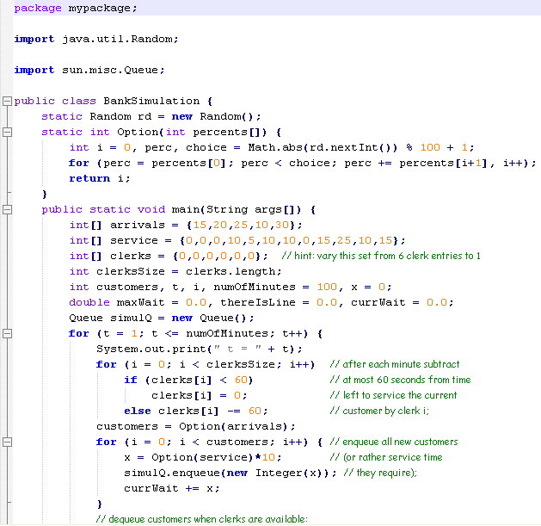
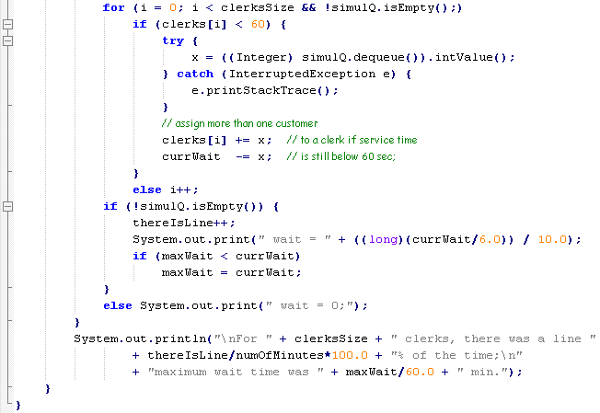

Code Development for (Step 1):
package bankSimulation;
import java.util.Random;

import sun.misc.*;

public class BankSimulation {

static Random rd = new Random();
static int Option(int percents[]){
int i = 0, perc, choice = Math.abs(rd.nextInt()) % 100 +1;
for (perc = percents[0]; perc < choice; perc += percents[i+1], i++);
return i;
}

@SuppressWarnings("unchecked")
public static void main(String[] args) {
// TODO Auto-generated method stub
int[] arrivals = {15,20,25,10,30};
int[] service = {0,0,0,10,5,10,10,0,15,25,10,15};
int[] clerks = {0,0,0,0,0};
int clerksSize = clerks.length;
int customers, t, i, numOfMinutes = 100, x = 0;
double maxWait = 0.0, thereIsLine = 0.0, currWait = 0.0;
Queue simulQ = new Queue();

for(t = 1; t <= numOfMinutes; t++){
System.out.print(" t = " + t);
for(i = 0; i < clerksSize; i++)
if(clerks[i] < 60)
clerks[i] = 0;
else clerks[i] -= 60;
customers = Option(arrivals);
for(i = 0; i < customers; i ++){
x = Option(service)*10;
simulQ.enqueue(new Integer(x));
currWait += x;
}
for(i = 0; i < clerksSize && !simulQ.isEmpty();)
if(clerks[i] < 60){
try{
x = ((Integer) simulQ.dequeue()).intValue();
} catch (InterruptedException e){
e.printStackTrace();
}
clerks[i] += x;
currWait -= x;
}
else
i++;
if(!simulQ.isEmpty()){
thereIsLine++;
System.out.print(" wait = " + ((long)(currWait/6.0))/10.0);
if(maxWait < currWait)
maxWait = currWait;
}
else
System.out.print(" wait = 0;");
}
System.out.println("\nFor " + clerksSize + " clerks, there was a line "
+ thereIsLine/numOfMinutes*100.0 + "% of the time;\n"
+"maximum wait time was " + maxWait/60.0 + " min.");
}
}

Production Deployment for (Step 1):
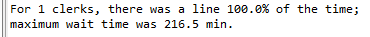
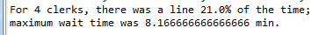
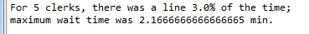
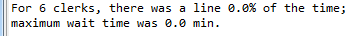
Make sure your output screen shot is readable, magnify if necessary so the instructor can easily read it. A sample magnified output is shown below; replace this with your own.

Code Changes and Production Deployment for (Step 2):
int[] clerks = {0}; =

int[] clerks = {0,0}; =

int[] clerks = {0,0,0}; =

int[] clerks = {0,0,0,0}; =

int[] clerks = {0,0,0,0,0}; =

int[] clerks = {0,0,0,0,0,0}; =

The idea here is to tell a story: here’s the code I changed and its associated output. Then I change the code to this and I got this output. And so on and so forth! Feel free to use your creative imagination when laying out the code changes and its associated outputs.

(Step 3) Recommendation:

I recommend that Bank One hire 6 clerks.

(Step 4) Justification:

I ran this program for differing amounts of clerks multiple times, and all except for the run with 6 clerks yielded consistent wait times over 0. In contrast, 6 clerks generally kept the wait to 0, only occasionally yielding a wait time above 0. This will create a better customer experience, as well as provide a buffer for each clerk’s lunch break, and allow for more flexibility in scheduling. Additionally, if a clerk is out sick or on vacation the wait time will increase from an average of 0 to and average of 2.6 minutes- which is significant, but not nearly as significant as the increase if 5 clerks (avg wait time 2.1) was reduced to 4 clerks (avg wait time 8.1). This way the impact to customer is mitigated and business can continue without much disruption.
- Backup your work to your USB drive.

- Submit to Blackboard at the link where you got it.
Note:
- Submit back to Blackboard where you get it.
- 2-points deduction if you submit it on the wrong place.
- 2-points deduction if you did not follow these instructions.
- Make sure you submit it at the correct location where you got it.
GRADING RUBRIC
Grading Criteria | 3  Exceeds  Excellent  Epic Wow | 2  Meets  Satisfactory  O.K. | 1  Partially Meets  Below Expectations  Not Yet | 0  Does Not Meet  Unacceptable  Fail
Completeness | +6-Completed all the required work and excellent documentation. | +4-Completed all the work required. | +2-Partially completed the work required. | Unfortunately, did not complete the work required.
Recommendation | +6- Excellent recommendation. | +4-Recommendation is okay but could have been better. | +2-Recommendation partially meets company’s needs. | Unfortunately, there is no recommendation.
Justification | +7-Excellent justification. | +4-Justification is okay. | +2-Justification partially meets the company’s needs but could have been better. | Unfortunately, there is no justification.
Coding | +6- Code is working and all combinations worked. | +4-Code is O.K., and program works. | +2-Code works, but still needs improvement. | Unfortunately, code is not working.

